

Python Coding Basics

This document will guide you through the basics of computer programming in Python. This will be assuming that you have little to no knowledge of programming. This will walk you through the setup of your first Integrated Development Environment (IDE) and getting you through the basics of Python to be able to begin to create basic applications and solve basic coding problems. This guide will have you working through some basic projects that you are expected to figure out with the information you are given. However, if you are stuck and want to see how I coded it, you may take a look at the GitHub link that will contain my solutions.

**Setting up Python and your IDE**

First things first, let us make sure that Python is set up on your system. Head over to <https://www.python.org/downloads/> and download the latest version.

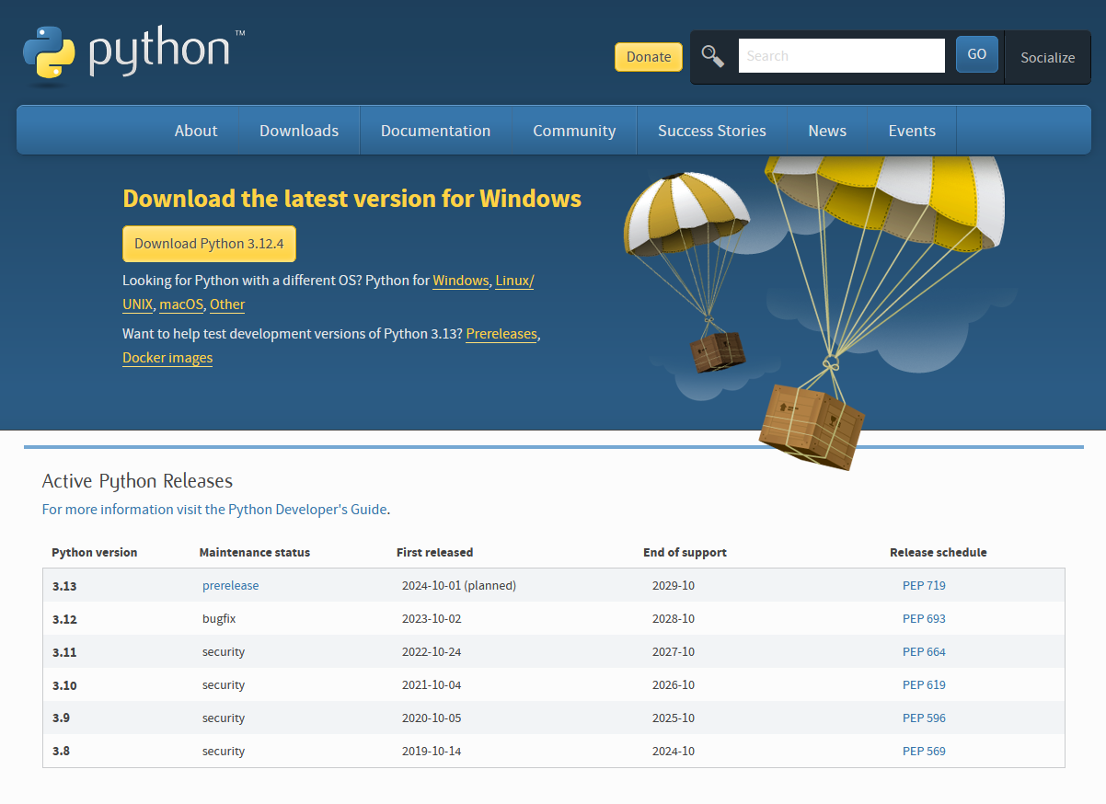

Once downloaded, run the installer and ensure that you have checked the box to add Python.exe the PATH.

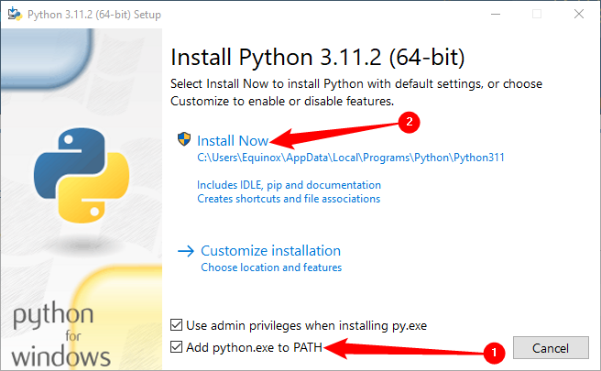

Once the installer has fully finished installing Python, you are ready to begin coding. To start, search for the program called “IDLE”. Once you have it open, you should be greeted with this screen:

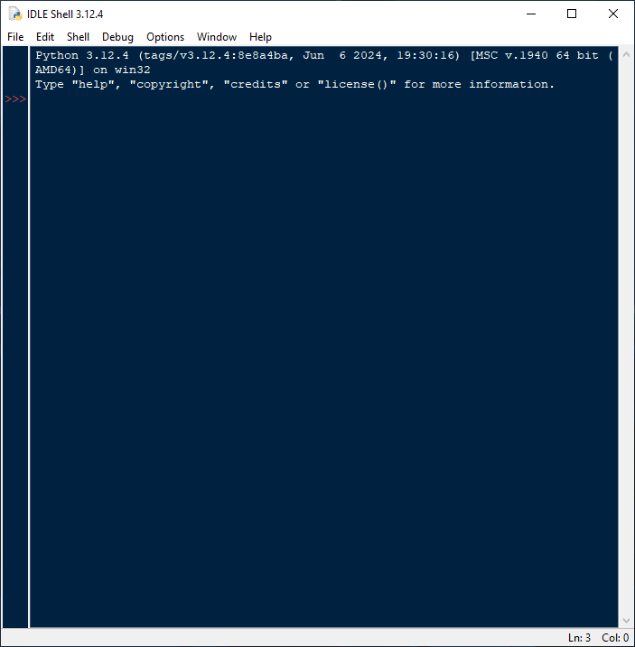

This program is your Integrated Development Environment or IDE for short. An IDE is a set of tools such as a code editors and debuggers that are used for software development. There are plenty of IDEs out there that you can explore in the future such as Visual Studio Code, IntelliJ, NetBeans, PyCharm, etc. However, for the process of simplicity since it comes with the Python install, we shall use IDLE, which will be sufficient for learning the basics of Python. To start, click on “File” and then create a new file.

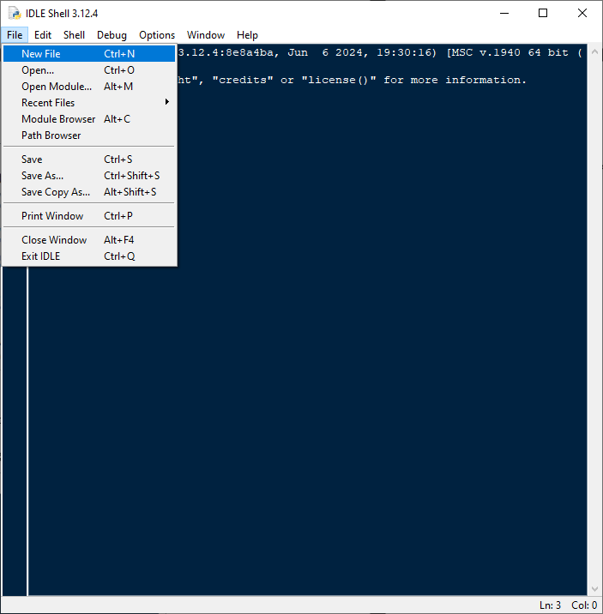

**Creating your first program**

Let’s start by writing your first program. A mainstay in programming is to begin by printing “Hello World!” as the output. Let’s learn how to do that in Python. Let us talk about our first function, which will be **Print**. Before I tell you how this function works, it may be important to understand what is a “function” in terms of programming. A function is a modular unit of code that can be called upon to perform specific tasks. In most programming languages, there will be pre-defined functions built right out of the box or in a library that you can import in. However, once you have more programming experience, you can and should create your own functions to prevent needless repetition of long blocks of code in your program which will make the code much easier to read not only for yourself but for any future coder that might need to make modifications to your code. However, let’s not worry about creating our own functions and stick to the pre-defined ones.

**Print** is a function that will “print” data into the output console. The format is **print ({Integer, String, etc.})**. Replace everything between “()” with the data that you want to output to the console. For example, **print (“Hello”)** will output **Hello** to the console. With this knowledge, let’s print “Hello World” to the output. I’ll show you how to do this for this first program.

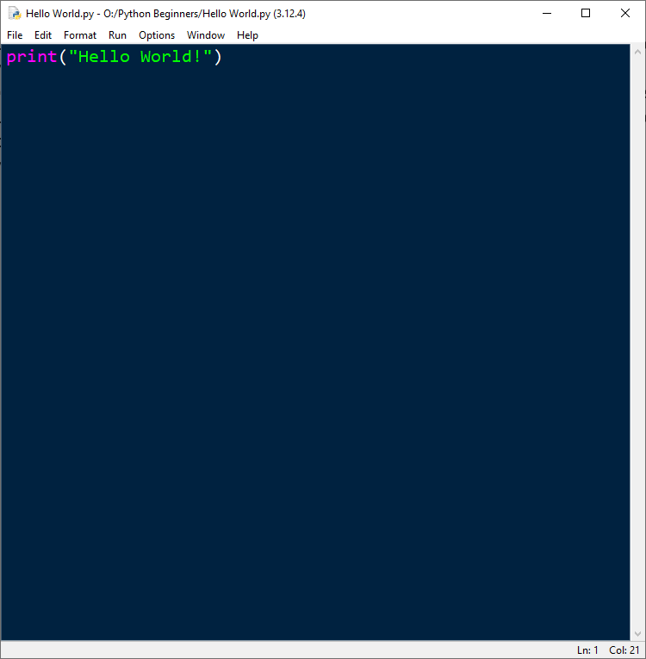

Follow along with me and write out this line of code in your IDE. Once you are done, save the program and then click on **Run -> Run Module** in order to see your code get executed. You should see an output similar to mine.

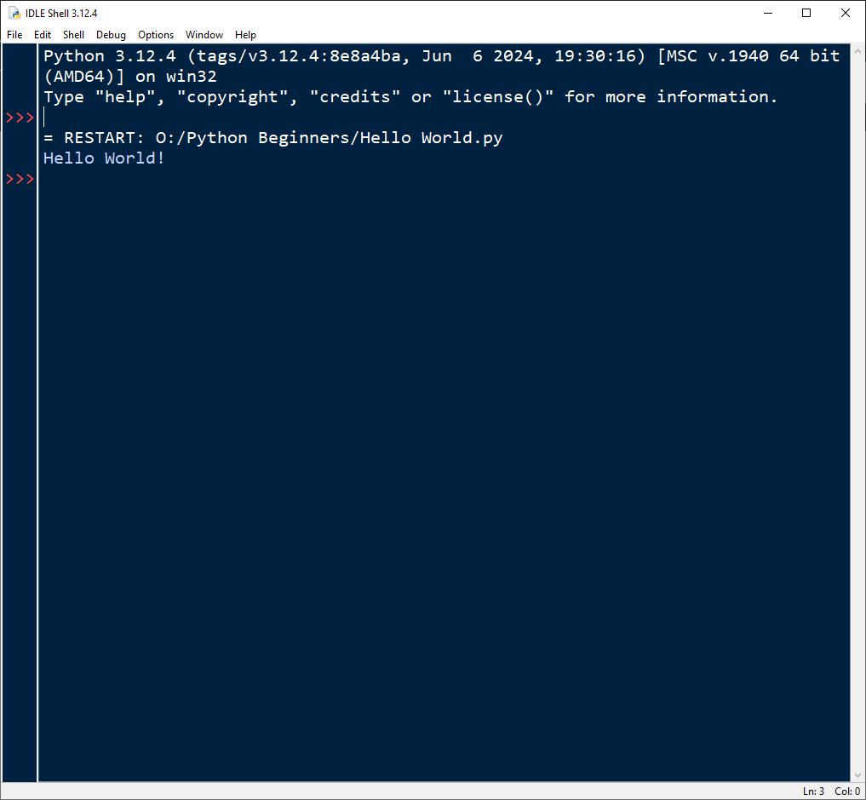

Congratulations! You have written your first program! If you want, you may try to explore the **print** function more. Try changing the words within the quotation marks, writing another print statement, maybe even removing everything between the parenthesis and then running it. Explore a little then let us move on to variables and data types.

